[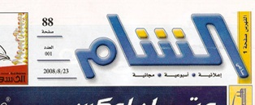](http://www.syriandays.com/?page=show_det&select_page=53&id=11319)